Exploring Factors Associated with Low Birthweight

Sahil Chitnis, ID = 23100637

17 October, 2023

# Exploratory data analysis

In this assignment you will carry out an **exploratory data analysis** of factors thought to be associated with low birthweight. The factors of interest are maternal smoking during pregnancy, history of premature labour, and number of visits to a physician in first trimester (the first trimester is the first three months of the pregnancy). The goal of the exploratory data analysis is to gain a better understanding of these factors and their associations with low birthweight in our dataset.

## Load the Libraries and Data Needed

The dataset you will be using is available in the aplore3 package and you will use the tidyverse package for data manipulation. You may not have these installed. If you get a yellow message to install one or both packages when you open this document in Rstudio, click on install. If you need to install them manually then remove the # and run following code in $\text{R}$. You will only need to install the packages once.

# install.packages("tidyverse")   
# install.packages("aplore3")

Load the required packages and make the birthweight dataset, lowbwt available using the data function as follows:

library(tidyverse)  
library(aplore3)  
  
data(lowbwt)

The low birthweight data is from the textbook “Applied Logistic Regression” by Hosmer and Lemeshow. The data are on 189 babies born at the Bayside Medical Centre in Massachusetts, in 1986. The following is a description of the variables in this dataset.

| Name | Description |
| --- | --- |
| subject | identification code |
| low | low birthweight (“< 2500 g” or “>= 2500 g”) |
| age | age of mother |
| lwt | weight at last menstrual period (pounds) |
| race | race (Black, White, Other) |
| smoke | smoked during pregnancy (Yes, No) |
| ptl | premature labour history (None, One, Two, etc.) |
| ht | history of hypertension (Yes, No) |
| ui | uterine irritability (Yes, No) |
| ftv | number of visits to physician during 1st trimester (three categories: None, One, Two, etc.) |
| bwt | birthweight (in grams) |

# Tabulations

The key variable of interest is low which represents whether a baby is born low birthweight, defined as a birthweight below 2,500 grams.

lowbwt %>% select(low) %>% table()

## low  
## >= 2500 g < 2500 g   
## 130 59

The tabulation shows 59 of the babies were low birthweight, and 130 were not low birthweight.

Let’s explore the association between smoking during pregnancy and low birthweight by cross-tabulating the two variables low and smoke.

lowbwt %>% select(smoke, low) %>% table()

## low  
## smoke >= 2500 g < 2500 g  
## No 86 29  
## Yes 44 30

From the cross-tabulation, we see that in this dataset 44+30 = 74 mothers smoked during pregnancy, and 86+29=115 did not. It seems the proportion of low birthweight babies is higher for mothers who smoked during pregnancy than those who did not smoke - let’s calculate row percentages so we can compare the proportion of low birthweight babies for mothers who smoked with the proportion of low birthweight babies for mothers who did not smoke.

lowbwt %>% select(smoke, low) %>% table() %>% prop.table(margin = 1)

## low  
## smoke >= 2500 g < 2500 g  
## No 0.7478261 0.2521739  
## Yes 0.5945946 0.4054054

We now explore the association between the mother having a history of any premature labour and low birthweight. First, in the following chunk, we recode the ptl variable into two categories, 0 for no premature labour and 1 for 1 or more premature labours, and call the new variable ptl_any.

lowbwt<-lowbwt %>%   
 mutate(ptl_any = ifelse(ptl =="None", 0, 1))

**Task 1**: In the following $\text{R}$ chunk explore the association between whether the mother had any previous premature labour (ptl_any) and whether the baby was born with low birthweight (low), using both counts and appropriate proportions/percentages. Describe your findings in 1-2 sentences.

**Findings**:Based on the output mothers who had any previous premature labor were more likely to have babies born with low birthweight.

count_table <- table(lowbwt$ptl_any, lowbwt$low)  
lowbwt %>% select(ptl_any, low) %>% table() %>% prop.table(margin = 1)

## low  
## ptl_any >= 2500 g < 2500 g  
## 0 0.7421384 0.2578616  
## 1 0.4000000 0.6000000

count_table

##   
## >= 2500 g < 2500 g  
## 0 118 41  
## 1 12 18

**Task 2**: In the following $\text{R}$ chunk explore the association between the number of visits to a physician in the first trimester (ftv) and whether the baby was born with low birthweight (low), using both the counts and appropriate proportions/percentages. Describe your findings in 1-2 sentences.

**Findings**:We can see that mothers who did not visit the physician not even once have lower percentage of babies born with higher birthweight as compared to mothers who had visited the physician at least once or twice.

count_table2 <- table(lowbwt$ftv, lowbwt$low)  
lowbwt %>% select(ftv, low) %>% table() %>% prop.table(margin = 1)

## low  
## ftv >= 2500 g < 2500 g  
## None 0.6400000 0.3600000  
## One 0.7659574 0.2340426  
## Two, etc. 0.7142857 0.2857143

count_table2

##   
## >= 2500 g < 2500 g  
## None 64 36  
## One 36 11  
## Two, etc. 30 12

# Barcharts

Now we will create some barcharts.

## Barchart of Low Birthweight

The following is a barchart of low birthweight status.

ggplot(lowbwt, aes(x = low, fill = low)) +  
 geom_bar()

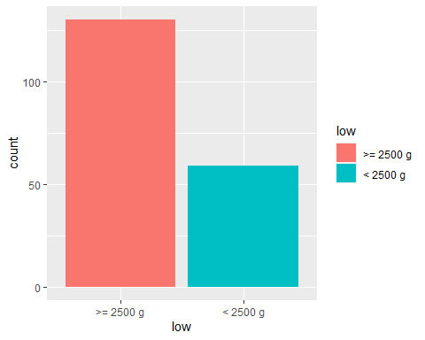

**Task 3**: In the following R chunk create a bar chart of smoking status of mothers.

ggplot(lowbwt, aes(x = smoke, fill = smoke)) +  
 geom_bar()

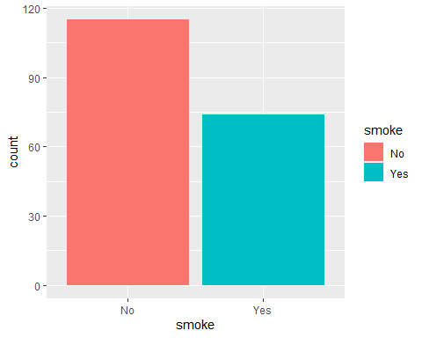

## Barchart of Low Birthweight by Smoking Status

Below is a stacked barchart of low birthweight of the babies by smoking status of mothers.

ggplot(lowbwt, aes(x = smoke)) +  
 geom_bar(aes(fill = low), position = "fill") +  
 ylab("Proportion")

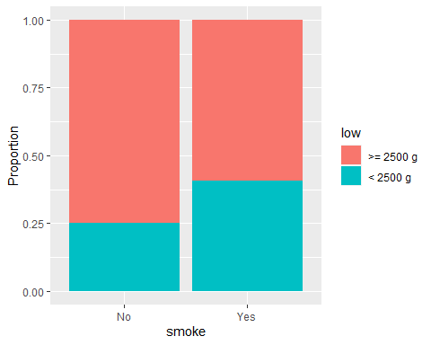

## Barchart of Low Birthweight by Preterm Labour

**Task 4**: Create a stacked barchart of low birthweight by any previous preterm labour (ptl_any) by writing appropriate code in the R chunk below.

ggplot(lowbwt, aes(x = ptl_any)) +  
 geom_bar(aes(fill = low), position = "fill")

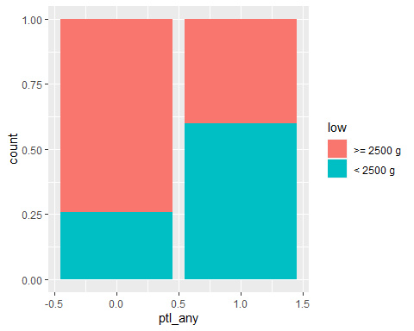

## Barchart of Low Birthweight by Number of Visits to Physician in first trimester

**Task 5**: Create a stacked barchart of low birthweight by number of visits to the physician in the first trimester by writing appropriate code in an R chunk below.

ggplot(lowbwt, aes(x = ftv)) +  
 geom_bar(aes(fill = low), position = "fill")

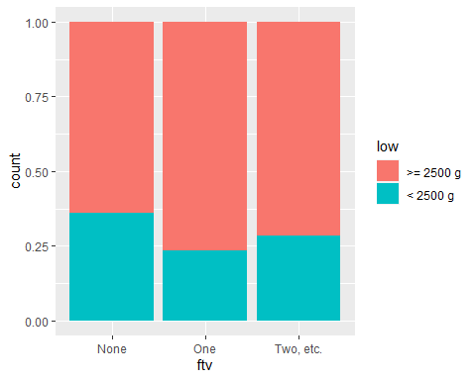

## Comments on barcharts

**Task 6**: Once you have created the plot write your interpretation of the association between with low birthweight and each of the three factors, based on the three barcharts. You should mention the direction and strength of each association. (2-3 sentences)

**Answer**:-

1. Smoking Status Factor:- Mothers who smoke during pregnancy have lower birthweight babies as compared to the mothers who don’t smoke. The barchart indicates a positive association between low birthweight babies and mothers who smoke during pregnancy.
2. Premature Labour Factor:- For Preterm labour factor there is a positive association between mothers who had a previous history of preterm labour and low birthweight babies, as mothers having previous history of preterm labour have higher chance of babies being born with lower birthweight
3. Number of physician visits during first trimester factor:- It can be observed that mothers who visited the physician once have higher birthweight babies(>2500) as compared to mothers who did not visit the physician. The barchart shoes there is a strong association among both the factors.

# Conclusion

**Task 7**: Based on the tabulations and bar charts, write a brief conclusion on whether you think the three factors (1) mother smoking during pregnancy, (2) any preterm labour, and (3) number of visits to a physician in the first trimester, could be useful to predict if a baby might be born with low birthweight. Do you think the relationships between low birthweight and these three factors you have observed in this dataset could be used to make inferences about the relationships in a wider population, and if so, what population?

**Answer**: Mothers smoking during pregnancy have a high risk of babies being born with low birthweight. If a mother had any preterm labour then also it is a major risk factor associated with low birthweight(from bar chart 2), moreover if a mother have had visited the physican more than once then the babies birhtweight seems to be less than 2500 grams, these graphs can help us determine if a particular baby will have a low birthweight or not. In addition to this, it can also be use to make inferences about the relationships among wider and demographic populations but more data might be required in order to make a strong inferences.

**Task 8**: “knit” the file as a Word (or PDF) document and submit the Word/pdf document to the Assignment 3 submission link on canvas before the deadline. **Do not submit the .Rmd document or you will lose marks**.